*Florida International University*

*School of Computing and Information Sciences*

CIS 4911 - Senior Capstone Project

Feature Document

User Story #1159

# Maintaining and Updating the Dev and Live Server

**Team Member:**

Joseph Gonzalez

**Product Owner(s)**:

Masoud Sadjadi

**Mentor(s)**:

Mohsen Taheri

**Instructor**: Masoud Sadjadi

# **User Story - Maintaining/Updating the Live and Dev Servers**

* As a developer I need to be able to test the site on the dev server, and then push to the live server once the code is ready.

## **Use Case**

**Use Case ID:** (VIP-1159)

**Details:** Maintaining/Updating the Live and Dev Servers

**Actor:** Developers

**Pre-Condition:**

* Developer has been given access rights to the vip server
* Developer has logged into the live server via Putty and WinSCP

**Description:**

1. Use Case begins when developer logs into the VIP dev server(vip-dev.cs.fiu.edu) via Putty and WinSCP
2. From WinSCP, developer navigates to the directory where they wish to run the dev server (/var/www/VIP4)
3. Developer must modify the following files in their code to run on the dev server
   1. Server.js
   2. Api/config/config
   3. api/config/auth.js

In all 3 of these files, the Developer must modify the lines referring to localhost or

vip.fiu.edu and replace them with the dev servers porting information (explained in

detail below)

1. Developer then make a zip file of the modified code
2. Developer then drags and drops the .zip file containing the dev_code from their system to the vip server
3. From putty, the developer now navigates to the same directory, and unpackages the zip file.
4. The developer navigates into Code file they’ve unpackaged and runs “forever start server.js”
5. Now the dev server should be running on vip-dev.cis.fiu.edu:8001
6. From here the developer now tests the site to ensure no bugs and errors. Once all is well, they must undo the changes made in step 3, and repeat steps 4-6.
7. Once ready to go live, disable the existing live server by running “forever stopall”
8. Finally, repeat step 7, and verify the server is live at vip.fiu.edu

**Post-Conditions:**

1. The Live server should now be running on the latest version of the code

**Alternative Course of Action**

* If updating the live server, follow same directions, but the live SSH into vip.fiu.edu for live server

**Exceptions:**

N/A

**Related Use Cases:**

Updating the Dev Server

**Decision Support:**

**Frequency:** Low: This occurs only a few times a semester.

**Criticality:** High: This task affects the live running version of the site, and involves testing for critical functionality of the site

**Risk:** High.

**Constraints:**

1. **Usability:** 
   1. Requires experience with linux server commands
2. **Reliability:** 
   1. Availability – A few times a semester.
3. **Performance:** 
   1. Site must be running stable on the live server
4. **Supportability:**
   1. All modern web browsers should be supported.

**Modification History:**

**Owner:** Joseph Gonzalez

**Initiation date:** 10/11/2016

**Date last modified:** 10/14/2016

**Use Case Diagram**

N/A

**Sequence Diagram**

N/A

**Class Diagram**

N/A

**Unit & Integration Tests:**

**Test Case 1 (Sunny Day)**

**ID: VIP-SD-1159-01**

**Purpose**

* Test that the dev server is running at the same time as the live server

**Precondition**

* Live server is currently running

**Input**

* The Dev Server is turned on and running

**Expected Result**

* The features run as intended

**Actual Result**

* Same as expected.

**Test Case 2 (Rainy Day)**

**ID: VIP-RD-1159-01**

**Purpose**

* Confirm the Dev code on the dev server is running

**Precondition**

* Dev server code has been updated

**Input**

* The Dev Server is turned on and running, and the new features are being tested

**Expected Result**

* The server crashes due to an error

**Actual Result**

* The server is able to run the new code without crashes or errors

**Test Case 3 (Sunny Day)**

**ID: VIP-SD-1159-03**

**Purpose**

* Test that the live server is now running with code updates

**Precondition**

* Live server code has been updated

**Input**

* The Live server is turned on with the new code

**Expected Result**

* The site runs as intended

**Actual Result**

* Same as expected.

**User Guide**

For this guide, I am going to go over how to update the Dev Server. For the Live server, do the exact same thing, but instead of logging into vip-dev.cs.fiu.edu via Putty and WinSCP you’ll be logging into vip.fiu.edu. All other instructions are the same.

So, first open WinSCP and login to the dev server (vip-dev.cs.fiu.edu)

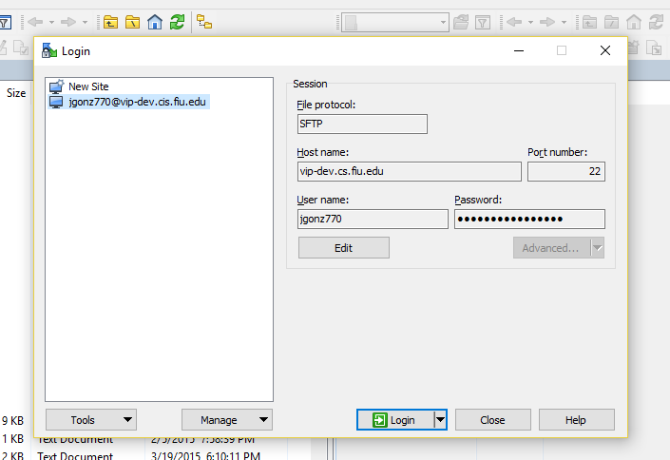

Login with your credentials, your email is your username (minus @fiu.edu) and your password (by default your password is the first letter of your first name, followed by your Panther ID, followed by the first letter of your last name such as “ e1234567g “.

From there, take note, the left half of the screen is your computer, the right half is the dev server. Navigate to which ever directory you want to run the dev server from (in my case /opt/users/jgonz770) and simply drag and drop a zipped version of your code from your computer to the dev server in WinSCP, in this example the file is named Code.zip. (In the event this is an update, first delete the existing Code.zip file in the dev server, before moving the new one into place)

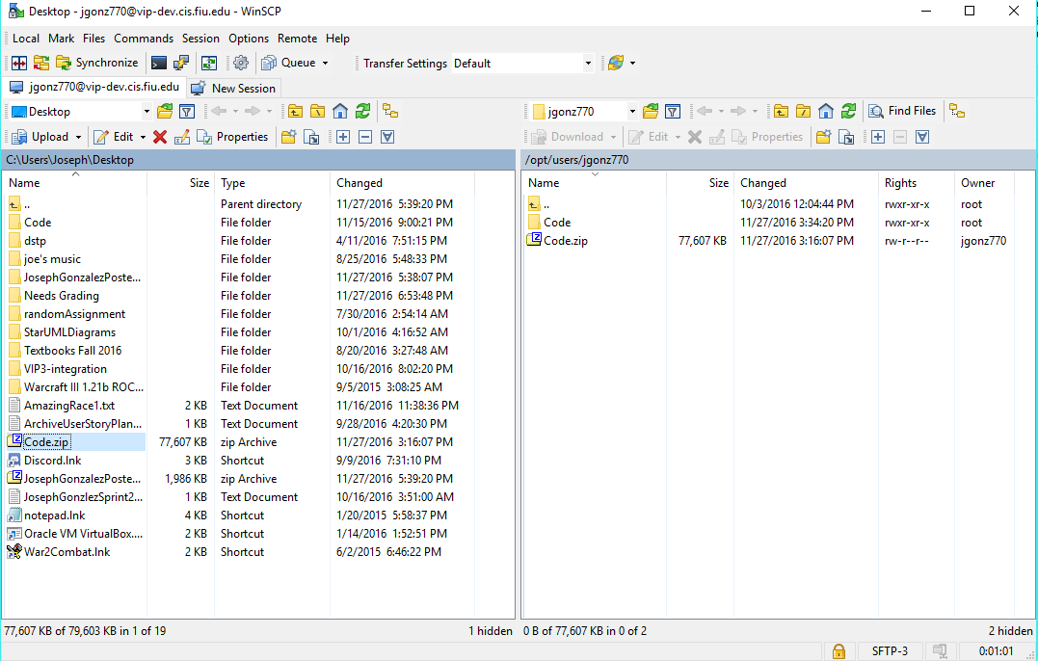

This is all we need to do in WinSCP, now open putty, login to the same site, and you will log in with the same credentials.

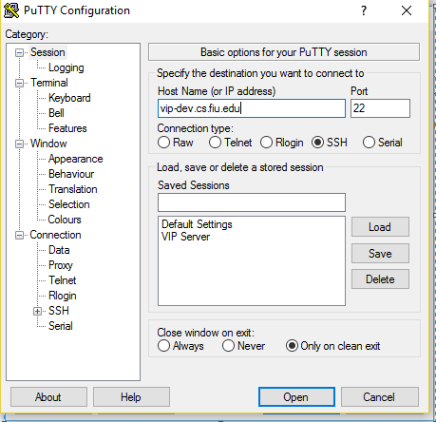

Your login credentials are the same as they were for WinSCP. Once logged in, you’ll need to become the root user. Simple enter “sudo su” then re-enter your password (by default Linux keeps passwords hidden, so don’t freak out if you don’t see anything while typing it in)

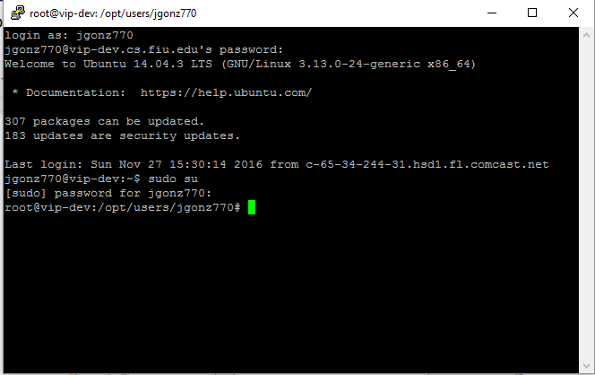

From here, navigate to the directory you placed the Code.zip file, and unzip it by entering “ unzip Code.zip “. (note, if you are performing an update, first delete the existing Code file by entering “ rm -rf Code “ ).

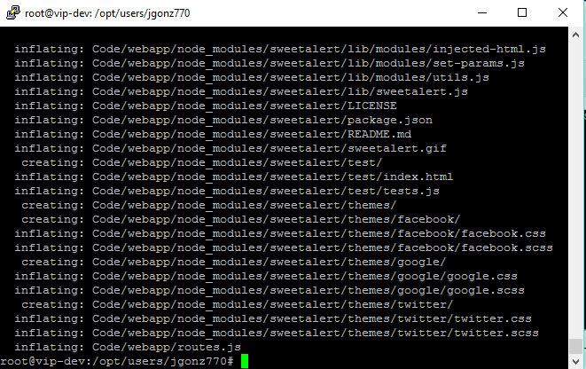

From here, navigate into the code file by entering “ cd Code “.



Now if you enter “forever list” you’ll see a list of all running processes on the forever node, this is used to run the site on the live server.

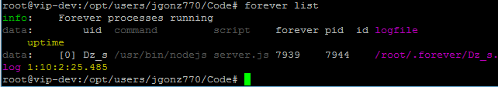

You are going to want to end the current processes by entering “ forever stopall “. Then simply start the site again by entering “forever start server.js”.

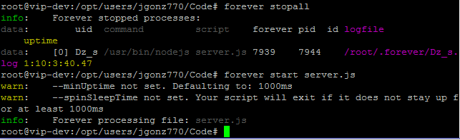

Now, pending you didn’t receive any error messages (this means there’s a problem in the code) the dev server is running on vip-dev.cs.fiu.edu

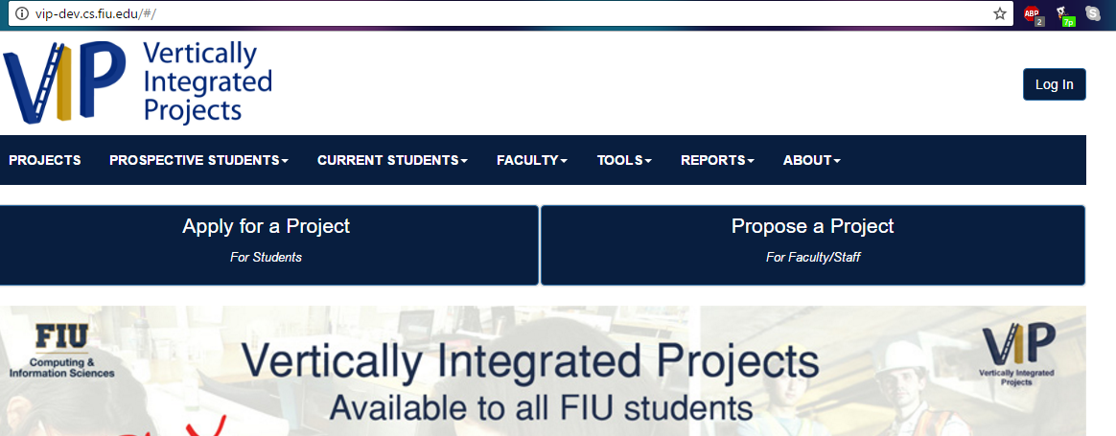

*Note that once you enter “forever stopall” the site will be down, so make sure you don’t run it until you are ready to run the updated Code.